【web开发一课程设计】

## 设计目的

1. 熟练掌握 HTML 在组织结构上的优势。

2. 熟练掌握 CSS 在网页布局中的应用。

3. 学习 Web 标准及浏览器的兼容性

## 设计步骤

1. 功能性需求分析

该网站共有4个页面，其中每一个页面的屏幕截图及主要功能如下所列。

（1） 首页：

屏幕截图：

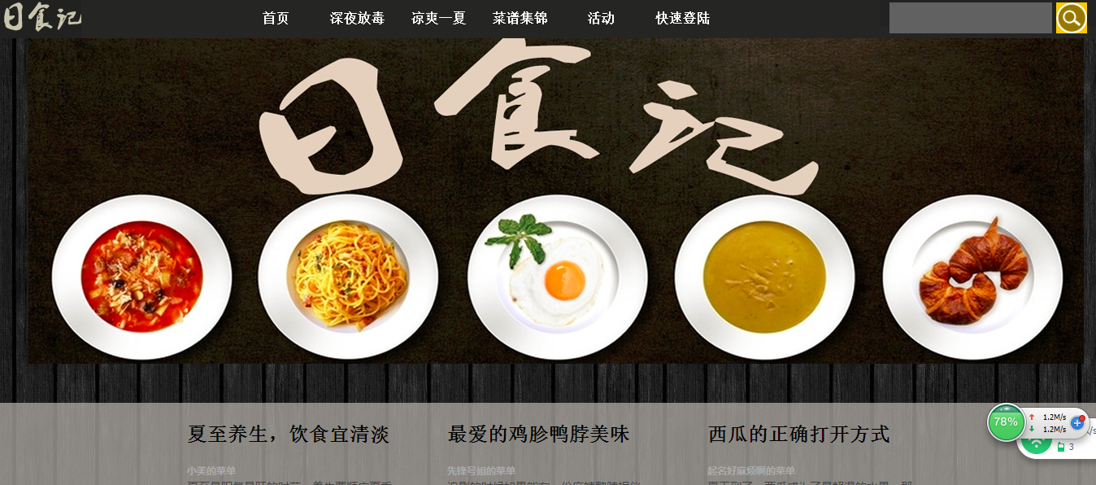

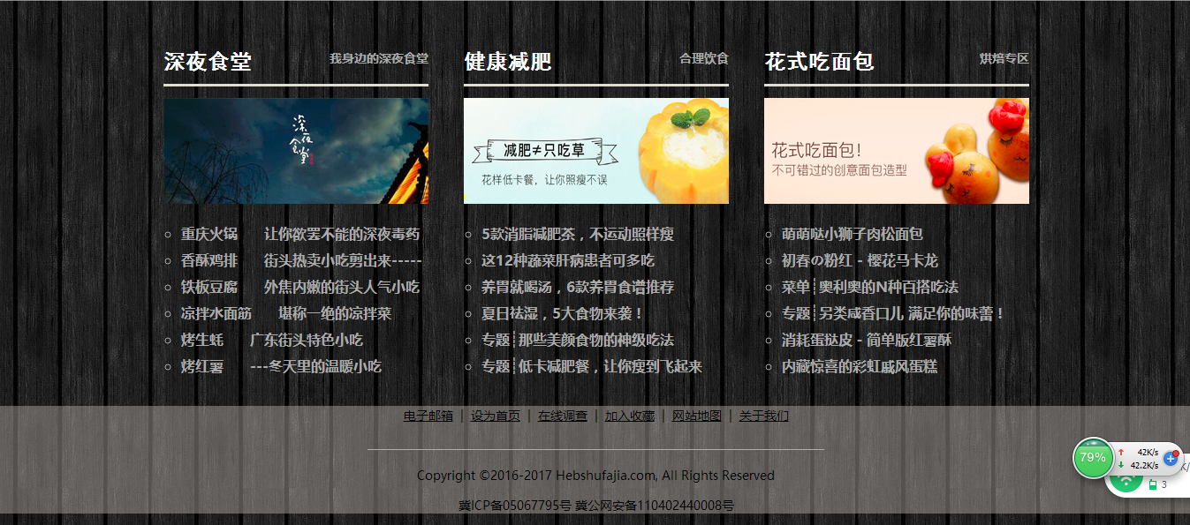

主要实现功能：

首页导航栏功能：跳转到其他页面，助于概括总体网页内容

首页搜索框：搜索内容，美化页面

首页banner：美化页面；明确页面方向

（2）二级页面：

屏幕截图：

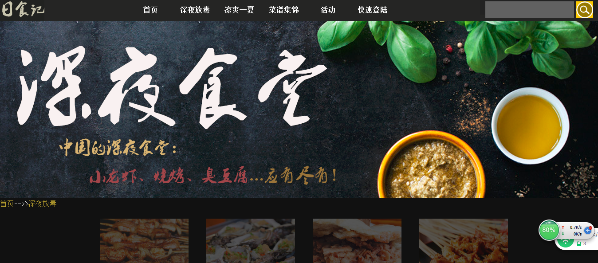

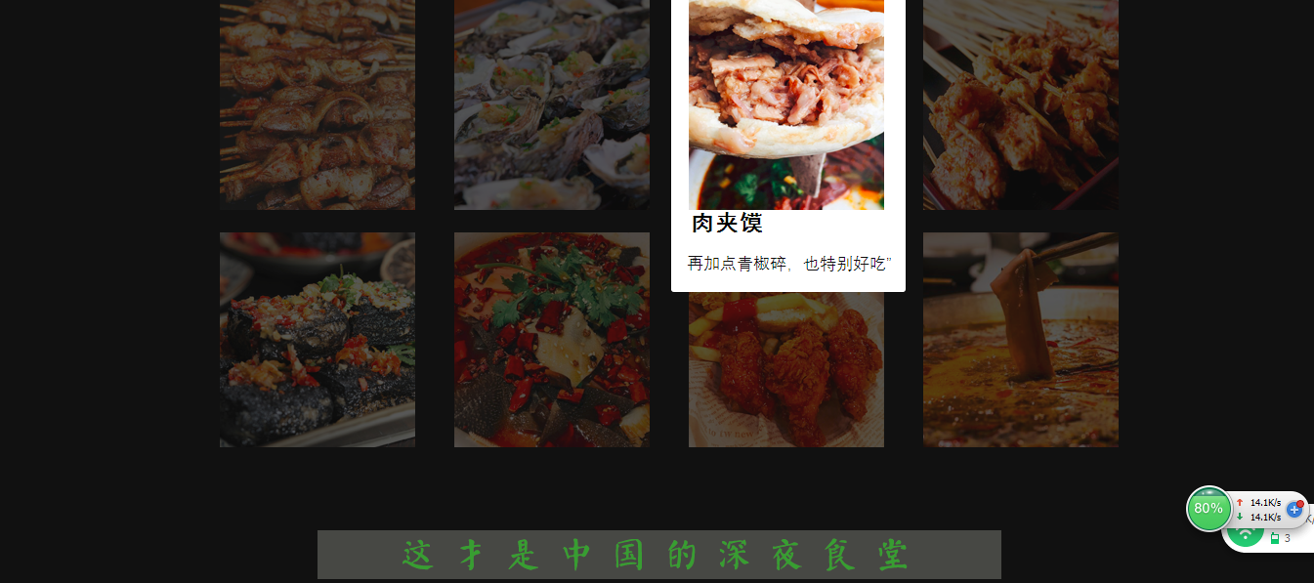

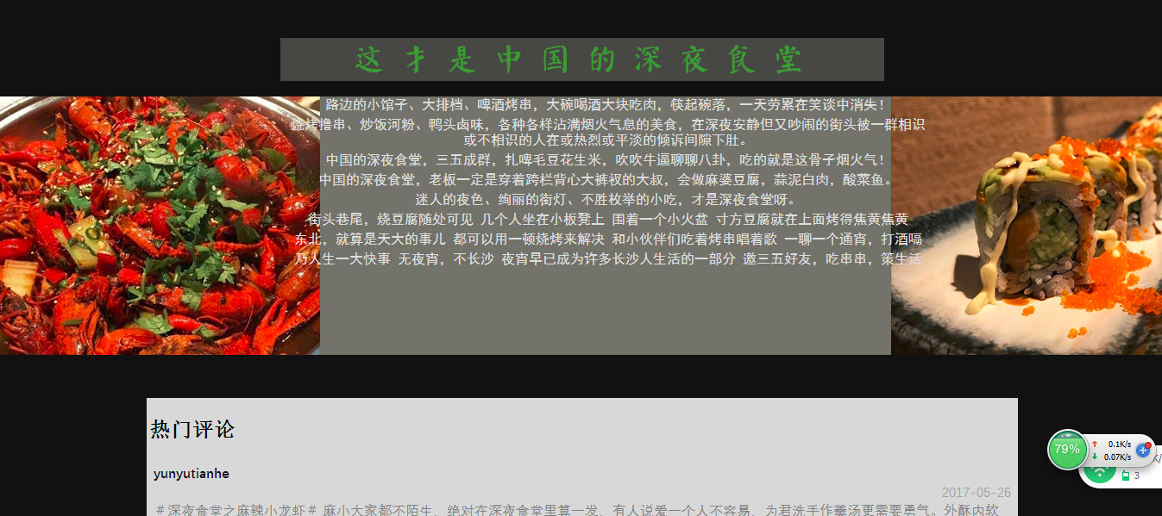

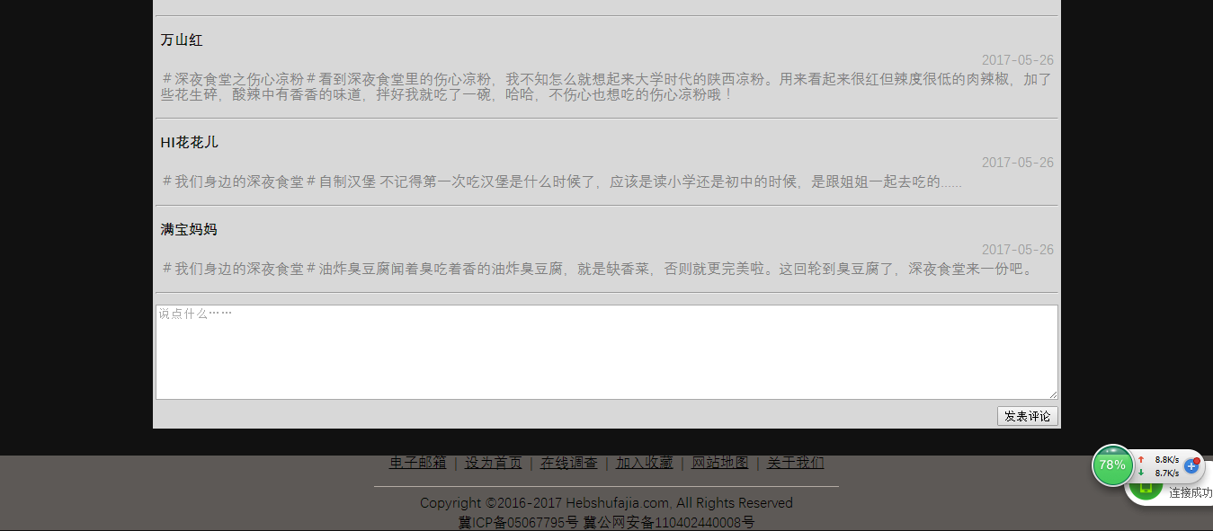

主要实现功能：

Banner：美化页面，

图片：美观，色彩丰富，吸引眼球，

评论：发表评论

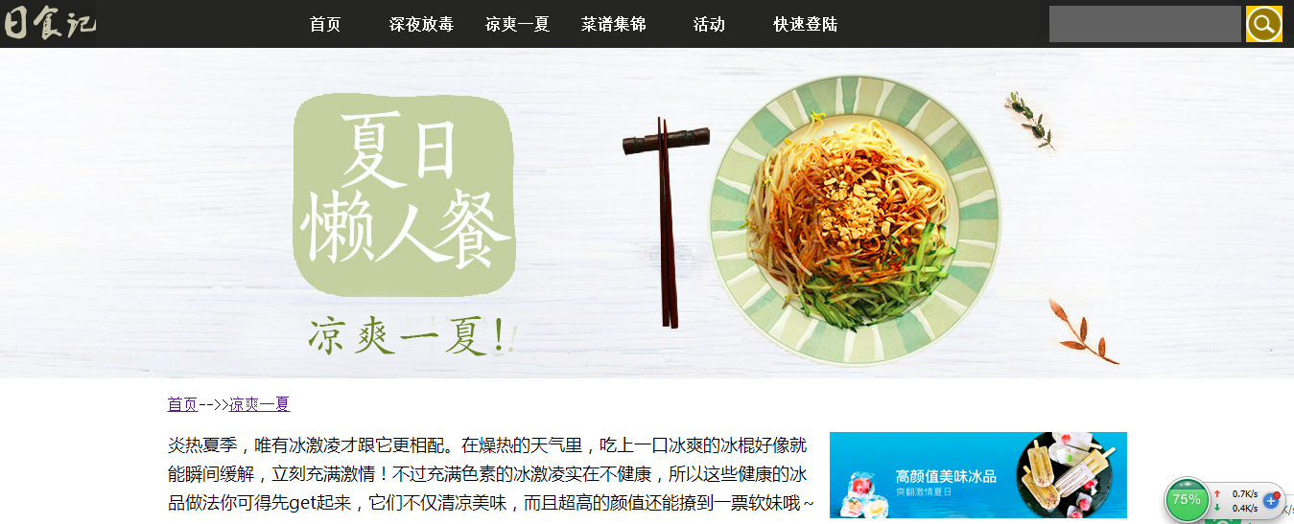

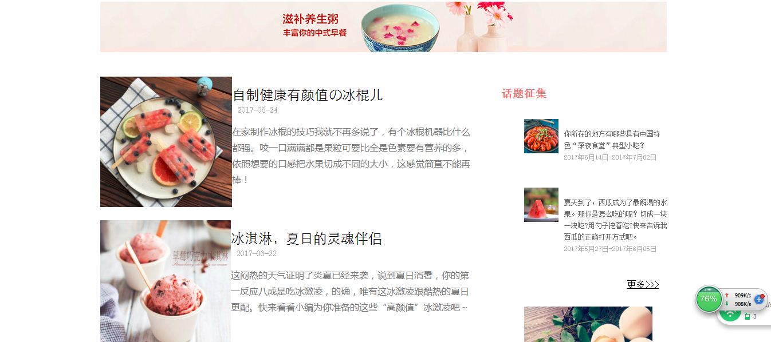

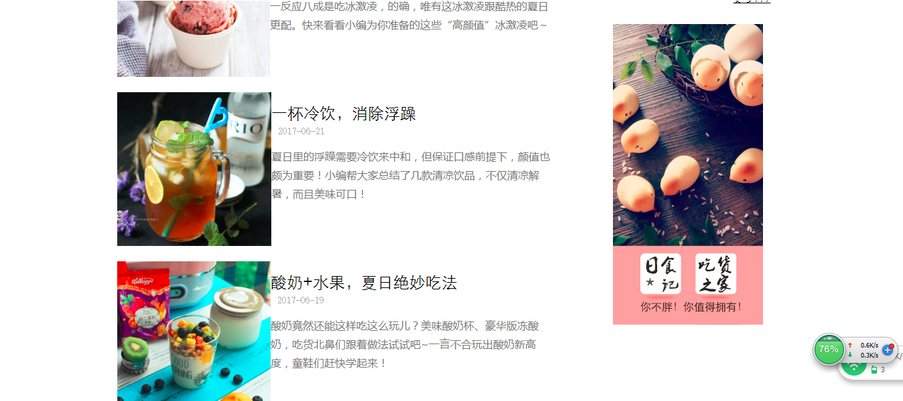

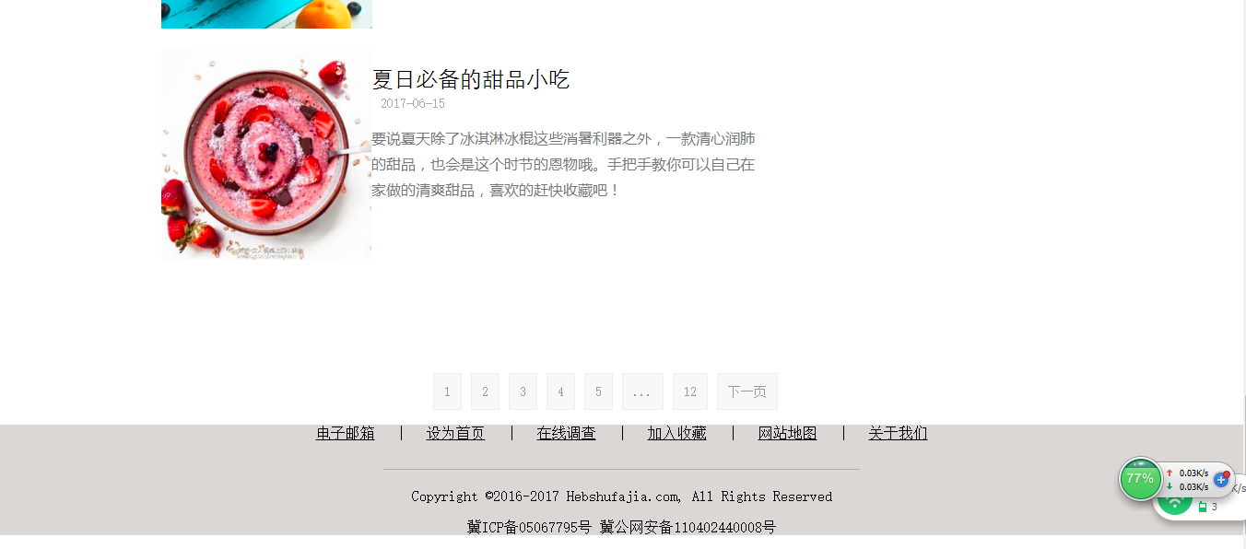

banner：美观

面包屑：明确所在位置

列表：概括夏季美食和活动内容

分页链接：转换到另一页

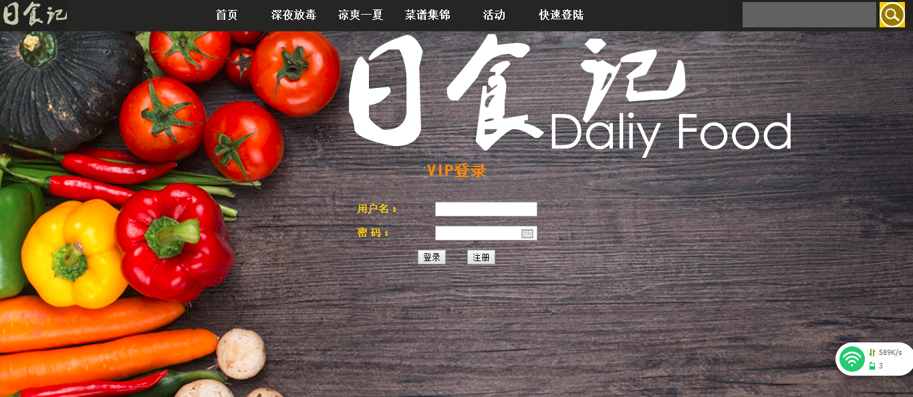

登陆：用户登录

2.搜集网站素材：美食网，搜狗图片，16素材网

3. 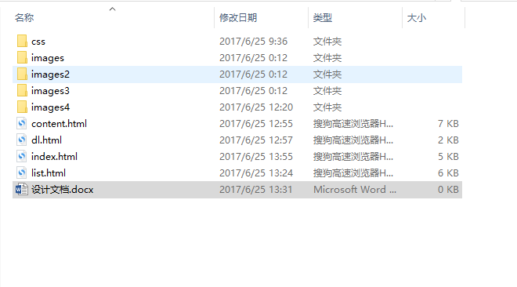

4.html

**(1）**首页

<!DOCTYPE html>

<html>

<head>

<title>日食记首页</title>

<meta charset="utf-8">

<link rel="stylesheet" type="text/css" href="css/index.css">

</head>

<body style="overflow-x: hidden;">

<div class="header">

<div class="nav">

<div class="logo">

<img src="images/logo.png">

</div>

<!--导航条-->

<div class="dh">

<a href="index.html" >首页</a>

<a href="content.html" target="_blank">深夜放毒</a>

<a href="list.html" target="_blank">凉爽一夏</a>

<a href="#">菜谱集锦</a>

<a href="#">活动</a>

<a href="dl.html">快速登陆</a>

</div>

<!--搜索框-->

<div id="sou">

<form method="get" id="searchform">

<fieldset class="search">

<input type="text" class="box" />

<button class="btn" title="Submit Search">Search</button>

</fieldset>

</form>

</div>

</div>

<!--banner-->

<div class="banner">

<img src="images/banner1.png">

</div>

</div>

<div class="clear"></div>

<!--中间-->

<div class="w2">

<div class="w">

<div class="m">

<a href="#"><h2>夏至养生，饮食宜清淡</h2></a>

<p>

<span>小美的菜单&nbsp;&nbsp;</span>

<br>

夏至是阳气最旺的时节，养生要顺应夏季阳盛于外的特点，注意保护阳气。</p>

</div>

<div class="m">

<a href="#"><h2>最爱的鸡胗鸭脖美味</h2></a>

<p>

<span>先锋号姐的菜单&nbsp;&nbsp;</span>

<br>

追剧的时候如果能有一份麻辣鸭脖相伴，那简直不能太棒了！原来大神们都是这样做的！</p>

</div>

<div class="m">

<a href="#"><h2>西瓜的正确打开方式</h2></a>

<p>

<span>起名好麻烦啊的菜单&nbsp;&nbsp;</span>

<br>

夏天到了，西瓜成为了最解渴的水果。那你是切成块吃？用勺子挖着吃？</p>

</div>

</div>

</div>

<div class="q">

<div class="qq">

<div class="r">

<a href="content.html" class="sy1">深夜食堂</a><span class="sy2">我身边的深夜食堂</span>

<br>

<img src="images/ee.png">

</div>

<div class="r1">

<img src="images/q2.png">

</div>

<div class="r2">

<div class="a1">

<ul type="circle">

<li><a href="#">重庆火锅&nbsp;&nbsp;&nbsp;&nbsp;&nbsp;&nbsp;让你欲罢不能的深夜毒药</a></li>

<li><a href="#">香酥鸡排&nbsp;&nbsp;&nbsp;&nbsp;&nbsp;&nbsp;街头热卖小吃剪出来-----</a></li>

<li><a href="#">铁板豆腐&nbsp;&nbsp;&nbsp;&nbsp;&nbsp;&nbsp;外焦内嫩的街头人气小吃</a></li>

<li><a href="#">凉拌水面筋&nbsp;&nbsp;&nbsp;&nbsp;&nbsp;&nbsp;堪称一绝的凉拌菜</a></li>

<li><a href="#">烤生蚝&nbsp;&nbsp;&nbsp;&nbsp;&nbsp;&nbsp;广东街头特色小吃</a></li>

<li><a href="#">烤红薯&nbsp;&nbsp;&nbsp;&nbsp;&nbsp;&nbsp;---冬天里的温暖小吃</a></li>

</div>

</div>

</ul>

</div>

<div class="qq">

<div class="r">

<span class="sy1">健康减肥</span><span class="sy2">合理饮食</span>

<br>

<img src="images/ee.png">

</div>

<div class="r1">

<img src="images/q1.png">

</div>

<div class="r2">

<div class="a2">

<ul type="circle">

<li><a href="#">5款消脂减肥茶，不运动照样瘦</a></li>

<li><a href="#">这12种蔬菜肝病患者可多吃</a></li>

<li><a href="#">养胃就喝汤，6款养胃食谱推荐</a></li>

<li><a href="#">夏日祛湿，5大食物来袭！</a></li>

<li><a href="#">专题┊那些美颜食物的神级吃法</a></li>

<li><a href="#">专题┊低卡减肥餐，让你瘦到飞起来</a></li>

</ul>

</div>

</div>

</div>

<div class="qq">

<div class="r">

<span class="sy1">花式吃面包</span><span class="sy2">烘焙专区</span>

<br>

<img src="images/ee.png">

</div>

<div class="r1">

<img src="images/q3.png">

</div>

<div class="r2">

<div class="a3">

<ul type="circle">

<li><a href="#">萌萌哒小狮子肉松面包</a></li>

<li><a href="#">初春の粉红 - 樱花马卡龙</a></li>

<li><a href="#">菜单┊奥利奥的N种百搭吃法</a></li>

<li><a href="#">专题┊另类咸香口儿 满足你的味蕾！</a></li>

<li><a href="#">消耗蛋挞皮－简单版红薯酥</a></li>

<li><a href="#">内藏惊喜的彩虹戚风蛋糕</a></li>

</ul>

</div>

</div>

</div>

</div>

<div class="clear"></div>

<!--页脚部分-->

<div class="footer">

<div>

<p>

<a href="#">电子邮箱</a>

&nbsp;|&nbsp;

<a href="#">设为首页</a>

&nbsp;|&nbsp;

<a href="#">在线调查</a>

&nbsp;|&nbsp;

<a href="#">加入收藏</a>

&nbsp;|&nbsp;

<a href="#">网站地图</a>

&nbsp;|&nbsp;

<a href="#">关于我们</a>

</p>

</div>

<div>

<p>

<img src="images/line1.png">

</p>

</div>

<div>

<p>Copyright ©2016-2017 Hebshufajia.com, All Rights Reserved</p>

<p>冀ICP备05067795号 冀公网安备110402440008号</p>

</div>

</div>

</body>

</html>

**(2）**内容页

<!DOCTYPE html>

<html>

<head>

<title>深夜放毒</title>

<meta charset="utf-8">

<link rel="stylesheet" type="text/css" href="css/content.css">

</head>

<body style="overflow-x: hidden;">

<div class="header">

<div class="nav">

<div class="logo">

<img src="images/logo.png">

</div>

<!--导航条-->

<div class="dh">

<a href="index.html">首页</a>

<a href="content.html">深夜放毒</a>

<a href="list.html" >凉爽一夏</a>

<a href="#">菜谱集锦</a>

<a href="#">活动</a>

<a href="dl.html">快速登陆</a>

</div>

<!--搜索框-->

<div id="sou">

<form method="get" id="searchform">

<fieldset class="search">

<input type="text" class="box" />

<button class="btn" title="Submit Search">Search</button>

</fieldset>

</form>

</div>

</div>

</div>

<div class="banner">

<img src="images2/banner2.png">

</div>

<div class="top1"><a href="index.html">首页</a>-->><a href="#">深夜放毒</a></div>

<div>

<ul class="gnineh">

<li>

<a href="#"><img src="images2/1.png" alt=""></a>

<div class="info">

<h2>深夜烧烤</h2>

<p>无论烤肉、烤昆虫、烤蔬菜

烧烤透着精细</p>

</div>

</li>

<li>

<a href="#"><img src="images2/2.png" alt=""></a>

<div class="info">

<h2>烤生蚝</h2>

<p>海蛎子，入口鲜嫩</p>

</div>

</li>

<li>

<a href="#"><img src="images2/3.png" alt=""></a>

<div class="info">

<h2>肉夹馍</h2>

<p>“再加点青椒碎，也特别好吃”</p>

</div>

</li>

<li>

<a href="#"><img src="images2/4.png" alt=""></a>

<div class="info">

<h2>玉林串串香</h2>

<p>厚重的牛油，嫩滑的牛肉——最成都 </p>

</div>

</li>

<li>

<a href="#"><img src="images2/5.png" alt=""></a>

<div class="info">

<h2>臭豆腐</h2>

<p>魂牵梦绕，欲罢不能 </p>

</div>

</li>

<li>

<a href="#"><img src="images2/6.png" alt=""></a>

<div class="info">

<h2>毛血旺</h2>

<p>一锅红彤彤煮好的热菜，

汤色油亮，辣椒喷香</p>

</div>

</li>

<li>

<a href="#"><img src="images2/7.png" alt=""></a>

<div class="info">

<h2>炸鸡</h2>

<p>一口咬下，嫩香四溢的鸡肉在口腔里爆炸啦，再来一口凉透全身的啤酒，爽歪歪！</p>

</div>

</li>

<li>

<a href="#"><img src="images2/8.png" alt=""></a>

<div class="info">

<h2>火锅</h2>

<p>“一锅一味，两城两心，一颗通往专注，一颗通往自由。”</p>

</div>

</li>

</ul>

</div>

<div style="clear:both"></div>

&nbsp;<br>

&nbsp;<br>

&nbsp;<br>

&nbsp;<br>

<div class="nr">

<div class="nt">

<img src="images2/biaoti.png">

</div>

<div class="nr1">

<div class="nr2">

<p>路边的小馆子、大排档、啤酒烤串，大碗喝酒大块吃肉，筷起碗落，一天劳累在笑谈中消失！</p>

<p>烧烤撸串、炒饭河粉、鸭头卤味，各种各样沾满烟火气息的美食，在深夜安静但又吵闹的街头被一群相识或不相识的人在或热烈或平淡的倾诉间隙下肚。</p>

<p>中国的深夜食堂，三五成群，扎啤毛豆花生米，吹吹牛逼聊聊八卦，吃的就是这骨子烟火气！</p>

<p>中国的深夜食堂，老板一定是穿着跨栏背心大裤衩的大叔，会做麻婆豆腐，蒜泥白肉，酸菜鱼。</p>

<p>迷人的夜色、绚丽的街灯、不胜枚举的小吃，才是深夜食堂呀。</p>

<p>街头巷尾，烧豆腐随处可见

几个人坐在小板凳上

围着一个小火盆

寸方豆腐就在上面烤得焦黄焦黄</p>

<p>东北，就算是天大的事儿

都可以用一顿烧烤来解决

和小伙伴们吃着烤串唱着歌

一聊一个通宵，打酒嗝</p>

<p>乃人生一大快事

无夜宵，不长沙

夜宵早已成为许多长沙人生活的一部分

邀三五好友，吃串串，策生活</p>

</div>

</div>

</div>

<!--评论表单-->

<div class="table">

<form>

<table align="center" width="1000px">

<tr border="1px">

<td class="one"><h2>热门评论</h2></td>

</tr>

<tr>

<td><p><b><a href="#">yunyutianhe</a></b> </p><p class="two">2017-05-26</p><p><a href="#">＃深夜食堂之麻辣小龙虾＃

麻小大家都不陌生，绝对在深夜食堂里算一发，有人说爱一个人不容易，为君洗手作羹汤更需要勇气。外酥内软的虾肉总是令人食欲大增，做为一个吃货绝对不会放过酥脆的钳子，味道麻辣鲜香，质地嫩滑，滋味香辣酥麻，回味无穷，看着他吃也是一种幸福。</a></p></td>

</tr>

<tr><td><hr></td></tr>

<tr>

<td><p><b><a href="#">万山红　 </a></b></p><p class="two">2017-05-26</p><p><a href="#">＃深夜食堂之伤心凉粉＃看到深夜食堂里的伤心凉粉，我不知怎么就想起来大学时代的陕西凉粉。用来看起来很红但辣度很低的肉辣椒，加了些花生碎，酸辣中有香香的味道，拌好我就吃了一碗，哈哈，不伤心也想吃的伤心凉粉哦！ </a></p></td>

</tr>

<tr><td><hr></td></tr>

<tr>

<td><p><b><a href="#">HI花花儿 </a></b></p><p class="two">2017-05-26</p><p><a href="#">＃我们身边的深夜食堂＃自制汉堡 不记得第一次吃汉堡是什么时候了，应该是读小学还是初中的时候，是跟姐姐一起去吃的......</a></p></td>

</tr>

<tr><td><hr></td></tr>

<tr>

<td><p><b><a href="#">满宝妈妈　 </a></b></p><p class="two">2017-05-26</p><p><a href="#">＃我们身边的深夜食堂＃油炸臭豆腐闻着臭吃着香的油炸臭豆腐，就是缺香菜，否则就更完美啦。这回轮到臭豆腐了，深夜食堂来一份吧。</a></p></td>

</tr>

<tr><td><hr></td></tr>

<tr>

<td>

<textarea class="three" placeholder="说点什么……"></textarea>

</td>

</tr>

<tr>

<td align="right">

<input type="submit" value="发表评论">

</td>

</tr>

</table>

</form>

</div>

<div class="clear"></div>

<!--页脚部分-->

<div class="footer">

<div>

<p>

<a href="#">电子邮箱</a>

&nbsp;|&nbsp;

<a href="#">设为首页</a>

&nbsp;|&nbsp;

<a href="#">在线调查</a>

&nbsp;|&nbsp;

<a href="#">加入收藏</a>

&nbsp;|&nbsp;

<a href="#">网站地图</a>

&nbsp;|&nbsp;

<a href="#">关于我们</a>

</p>

</div>

<div>

<p>

<img src="images/line1.png">

</p>

</div>

<div>

<p>Copyright ©2016-2017 Hebshufajia.com, All Rights Reserved</p>

<p>冀ICP备05067795号 冀公网安备110402440008号</p>

</div>

</div>

</body>

</html>

**（3）**列表页

<!DOCTYPE html>

<html>

<head>

<title>凉爽一夏</title>

<meta charset="utf-8">

<link rel="stylesheet" type="text/css" href="css/list.css">

</head>

<body style="overflow-x: hidden;">

<!--头部-->

<div class="header">

<div class="nav">

<div class="logo">

<img src="images/logo.png">

</div>

<!--导航条-->

<div class="dh">

<a href="index.html" >首页</a>

<a href="content.html">深夜放毒</a>

<a href="list.html">凉爽一夏</a>

<a href="#">菜谱集锦</a>

<a href="#">活动</a>

<a href="dl.html">快速登陆</a>

</div>

<!--搜索框-->

<div id="sou">

<form method="get" id="searchform">

<fieldset class="search">

<input type="text" class="box" />

<button class="btn" title="Submit Search">Search</button>

</fieldset>

</form>

</div>

</div>

</div>

<div class="banner">

<img src="images3/banner1.png">

</div>

<!--页面主体-->

<div class="content">

<div class="top">

<div class="top1"><a href="index.html">首页</a>-->><a href="#">凉爽一夏</a></div>

<div class="top_left">

<p>炎热夏季，唯有冰激凌才跟它更相配。在燥热的天气里，吃上一口冰爽的冰棍好像就能瞬间缓解，立刻充满激情！不过充满色素的冰激凌实在不健康，所以这些健康的冰品做法你可得先get起来，它们不仅清凉美味，而且超高的颜值还能撩到一票软妹哦～</p>

</div>

<div class="top_right">

<a href="#"><img src="images3/tr.png"></a>

</div>

</div>

<div class="mid"><a href="#"><img src="images3/mid.png"></a></div>

<div class="middle">

<div class="first">

<div class="one">

<img src="images3/one.png">

</div>

<div class="zi">

<a href="#">自制健康有颜值の冰棍儿</a><br>

<span>2017-06-24</span>

<p>在家制作冰棍的技巧我就不再多说了，有个冰棍机器比什么都强。咬一口满满都是果粒可要比全是色素要有营养的多，依照想要的口感把水果切成不同的大小，这感觉简直不能再棒！</p>

</div>

</div>

<div class="clear"></div>

<div class="second">

<div class="one">

<img src="images3/second.png">

</div>

<div class="zi">

<a href="#">冰淇淋，夏日的灵魂伴侣</a><br>

<span>2017-06-22</span>

<p>这闷热的天气证明了炎夏已经来袭，说到夏日消暑，你的第一反应八成是吃冰激凌，的确，唯有这冰激凌跟酷热的夏日更配。快来看看小编为你准备的这些“高颜值”冰激凌吧～</p>

</div>

</div>

<div class="clear"></div>

<div class="third">

<div class="one">

<img src="images3/third.png">

</div>

<div class="zi">

<a href="#">一杯冷饮，消除浮躁</a><br>

<span>2017-06-21</span>

<p>夏日里的浮躁需要冷饮来中和，但保证口感前提下，颜值也颇为重要！小编帮大家总结了几款清凉饮品，不仅清凉解暑，而且美味可口！</p>

</div>

</div>

<div class="clear"></div>

<div class="fourth">

<div class="one">

<img src="images3/four.png">

</div>

<div class="zi">

<a href="#">酸奶+水果，夏日绝妙吃法</a><br>

<span>2017-06-19</span>

<p>酸奶竟然还能这样吃这么玩儿？美味酸奶杯、豪华版冻酸奶，吃货北鼻们跟着做法试试吧~一言不合玩出酸奶新高度，童鞋们赶快学起来！</p>

</div>

</div>

<div class="clear"></div>

<div class="fifth">

<div class="one">

<img src="images3/five.png">

</div>

<div class="zi">

<a href="#">夏日必备的甜品小吃</a>

<br>

<span>2017-06-15</span>

<p>要说夏天除了冰淇淋冰棍这些消暑利器之外，一款清心润肺的甜品，也会是这个时节的恩物哦。手把手教你可以自己在家做的清爽甜品，喜欢的赶快收藏吧！</p>

</div>

</div>

<div class="clear"></div>

</div>

<div class="content_right">

<div class="title">

<h3>话题征集</h3>

</div>

<div class="list">

<ul>

<li><a href="#" ><img src="images3/xlx.png"></a><p><a href="#">你所在的地方有哪些具有中国特色“深夜食堂”典型小吃？</a><span>2017年6月14日-2017年7月02日</span></p></li>

<li><a href="#"><img src="images3/xg.png"></a><p><a href="#">夏天到了，西瓜成为了最解渴的水果。那你是怎么吃的呢？切成一块一块吃?用勺子挖着吃?快来告诉我西瓜的正确打开方式吧。</a><span>&nbsp;&nbsp;&nbsp;&nbsp;&nbsp;2017年5月27日-2017年6月05日</span></p></li>

<li><a href="#" class="gd">更多>>></a></li>

<li><img src="images3/zh.png"></li>

</ul>

</div>

</div>

</div>

<div class="clear"></div>

<div class="shu">

<a href="#" class="now">1</a>

<a href="#">2</a>

<a href="#">3</a>

<a href="#">4</a>

<a href="#">5</a>

<span>...</span>

<a href="#">12</a>

<a href="#" class="last">下一页</a>

</div>

<div class="clear"></div>

<!--页脚部分-->

<div class="footer">

<div>

<p>

<a href="#">电子邮箱</a>

&nbsp;|&nbsp;

<a href="#">设为首页</a>

&nbsp;|&nbsp;

<a href="#">在线调查</a>

&nbsp;|&nbsp;

<a href="#">加入收藏</a>

&nbsp;|&nbsp;

<a href="#">网站地图</a>

&nbsp;|&nbsp;

<a href="#">关于我们</a>

</p>

</div>

<div>

<p>

<img src="images/line1.png">

</p>

</div>

<div>

<p>Copyright ©2016-2017 Hebshufajia.com, All Rights Reserved</p>

<p>冀ICP备05067795号 冀公网安备110402440008号</p>

</div>

</div>

</body>

</html>

**（4）**登陆页

<!DOCTYPE html>

<html>

<head>

<title>快速登陆</title>

<meta charset="utf-8">

<link rel="stylesheet" type="text/css" href="css/dl.css">

</head>

<body>

<div class="header">

<div class="nav">

<div class="logo">

<img src="images/logo.png">

</div>

<!--导航条-->

<div class="dh">

<a href="index.html">首页</a>

<a href="content.html">深夜放毒</a>

<a href="list.html">凉爽一夏</a>

<a href="#">菜谱集锦</a>

<a href="#">活动</a>

<a href="dl.html">快速登陆</a>

</div>

<!--搜索框-->

<div id="sou">

<form method="get" id="searchform">

<fieldset class="search">

<input type="text" class="box" />

<button class="btn" title="Submit Search">Search</button>

</fieldset>

</form>

</div>

</div>

</div>

<!--表单-->

<div>&nbsp;</div>

<div class="table">

<table align="center" border="0" width="300" height="190" rules="none">

<tr>

<td colspan="2" align="center"><h2>VIP登录</h2></td>

</tr>

<tr>

<td>用户名：</td>

<td align="center"><input type="text"></td>

</tr>

<tr>

<td>密&nbsp;码：</td>

<td align="center"><input type="password"></td>

</tr>

<tr>

<td colspan="2" align="center">

<input type="submit" value="登录">&nbsp;&nbsp;&nbsp;&nbsp;&nbsp;&nbsp;&nbsp;

<a href="zhuce.html"><input type="button" value="注册"></a>

</td>

</tr>

</table>

</div>

</body>

</html>

5.css

**(1)**首页

body{

width:100%;

margin: 0;

background-image: url(../images/bg.jpg);

background-repeat: repeat;

}

.nav{

display: block;

width: 100%;

height: 50px;

background-image: url(../images/1.png);

float: left;

}

.logo{

float: left;

}

.dh{

float: left;

height: 50px;

margin:0px 190px;

width: 600px;

}

.dh a{

display: block;

float: left;

color: #fff;

width:100px;

height: 50px;

line-height: 50px;

font-weight: bolder;

text-align: center;

text-decoration: none;

}

.dh a:hover{

height: 50px;

color: #000;

background-color: #fff;

}

fieldset.search {

float: right;

border: none;

width: 243px;

height: 20px;

margin: 0 auto;

background: #222;

}

.search input, .search button {

border: none;

float: left;

}

.search input.box {

color: #fff;

font-size: 1.2em;

width: 190px;

height: 30px;

padding: 8px 5px 0;

background: #616161 no-repeat left top;

margin-right: 5px;

}

.search input.box:focus {

background: #616161 url(../images/sou.png) no-repeat left -38px;

outline: none;

}

.search button.btn {

width: 38px;

height: 38px;

cursor: pointer;

text-indent: -9999px;

background: #fbc900 url(../images/sou.png) no-repeat top right;

}

.w2{

margin-top: 45px;

width: 100%;

height: 150px;

background-image: url(../images/mbg.png);

}

.w{

margin-left: 200px;

width: 1000px;

}

.m{

float: left;

width: 260px;

height: 100px;

margin:5px 30px;

}

span{

color: #aaa;

font-size: 12px;

font-family: "微软雅黑";

font-weight: bolder;

}

h2{

color: #000

}

p{

color: #444;

font-family: "微软雅黑";

font-size: 14px;

}

.m a{

text-decoration: none;

}

.m h2:hover{

color: #f88;

text-decoration: underline;

}

.clear{

clear: both;

}

.q{

width: 1020px;

margin: 45px auto;

}

.qq{

width: 300px;

float: left;

margin: 10px 20px 0px 20px;

}

.sy1{

font-family: "黑体";

font-weight: bolder;

color: #fff;

text-decoration: none;

font-size: 24px;

}

.sy1:hover{

color: #f88;

text-decoration: underline;

}

.sy2{

font-size: 14px;

float: right;

}

.r1{

margin-top: 10px

}

.r2{

margin-left: -20px

}

.a1 ul li a{text-decoration: none;color: #aaa}

.a2 ul li a{text-decoration: none;color: #aaa}

.a3 ul li a{text-decoration: none;color: #aaa}

.a1 ul li a:hover{

color: #4197bc;

text-decoration: underline;

}

.a2 ul li a:hover{

color: #dff4f5;

text-decoration: underline;

}

.a3 ul li a:hover{

color: #ffebe0;

text-decoration: underline;

}

.qq ul li{

line-height: 30px;

color: #aaa;

font-family:"微软雅黑";

font-weight: bolder;

}

.footer{

text-align: center;

background-image: url(../images/footer.png);

}

.footer p{

color: #000

}

.footer p a{

color: #000

}

**（2）**内容页

body{

width:100%;

margin: 0;

background-color: #111

}

.nav{

display: block;

width: 100%;

height: 50px;

background-image: url(../images/1.png);

float: left;

}

.logo{

float: left;

}

.dh{

float: left;

height: 50px;

margin:0px 190px;

width: 600px;

}

.dh a{

display: block;

float: left;

color: #fff;

width:100px;

height: 50px;

line-height: 50px;

font-weight: bolder;

text-align: center;

text-decoration: none;

}

.dh a:hover{

height: 50px;

color: #000;

background-color: #fff;

}

fieldset.search {

float: right;

border: none;

width: 243px;

height: 20px;

margin: 0 auto;

background: #222;

}

.search input, .search button {

border: none;

float: left;

}

.search input.box {

color: #fff;

font-size: 1.2em;

width: 190px;

height: 30px;

padding: 8px 5px 0;

background: #616161 no-repeat left top;

margin-right: 5px;

}

.search input.box:focus {

background: #616161 url(../images/sou.png) no-repeat left -38px;

outline: none;

}

.search button.btn {

width: 38px;

height: 38px;

cursor: pointer;

text-indent: -9999px;

background: #fbc900 url(../images/sou.png) no-repeat top right;

}

.top1{color: #fff}

.top1 a{color: #b9a02e;text-decoration: none;}

.top1 a:hover{color: #fff;text-decoration: underline;}

ul.gnineh {width: 960px;list-style: none;margin: 15px auto;}

ul.gnineh li {width: 220px;float: left; display: inline;margin:10px; padding: 0;position: relative;}

ul.gnineh li:hover {z-index: 99;}

ul.gnineh li img {position: relative;filter: alpha(opacity=30);opacity: 0.3;-ms-filter:"progid:DXImageTransform.Microsoft.Alpha(Opacity=30)";}

ul.gnineh li:hover img{z-index: 999;filter: alpha(opacity=100);opacity: 1;-ms-filter: "progid:DXImageTransform.Microsoft.Alpha(Opacity=100)";}

ul.gnineh li .info {position: absolute;left: -18px; top: -10px;padding: 210px 10px 20px;width: 220px;display: none;background: #fff;font-size: 1.2em;-webkit-border-radius: 3px;-moz-border-radius: 3px;border-radius: 3px;}

ul.gnineh li:hover .info {display: block;}

ul.gnineh li h2 {font-size: 1.2em;font-weight: bolder;font-family:"黑体";text-transform: uppercase;margin: 10px; padding: 10px 0;}

ul.gnineh li p {padding: 0; margin: 0; font-size: 0.9em;}

.nr{

/*text-align: center;*/

width: 100%;

/*margin: 10px auto;*/

color: #fff;

text-align: center;

margin-bottom: 50px;

}

.nr img{

text-align: center;

margin-bottom: 10px

}

.nr1{

width: 100%;

background-image: url(../images2/bg.png);

background-repeat: no-repeat;

}

.nr2{

margin-left: 330px;

width: 750px;

height:300px;

text-align: center;

}

.nr2 p{

color: #ddd;

font-size: 16px;

font-family: "黑体"

}

.table{background:#d8d8d8;width:1010px;margin:30px auto;border:1px;}

.one{background-image:url('../images/lei5.png');}

.two{text-align:right;color:#a0a0a0;}

.three{height:100px;width:998px;}

b{font-size:16px;}

p{font-family:'等线';margin:5px;color:#101010;}

.table p a{text-decoration:none;color:#808080;margin:px auto;}

.table p a:hover{color:#303030;}

.table b a{text-decoration:none;color:#101010;}

.table b a:hover{color:#ffa500;}

.footer{

text-align: center;

background-image: url(../images/footer.png);

}

.footer p{

color: #000

}

.footer p a{

color: #000

}

**（3）**列表页

body{

margin:0px;

}

.clear{

clear: both;

}

.nav{

display: block;

width: 100%;

height: 50px;

background-image: url(../images/1.png);

float: left;

}

.logo{

float: left;

}

.dh{

float: left;

height: 50px;

margin:0px 190px;

width: 600px;

}

.dh a{

display: block;

float: left;

color: #fff;

width:100px;

height: 50px;

line-height: 50px;

font-weight: bolder;

text-align: center;

text-decoration: none;

}

.dh a:hover{

height: 50px;

color: #000;

background-color: #fff;

}

fieldset.search {

float: right;

border: none;

width: 243px;

height: 20px;

margin: 0 auto;

background: #222;

}

.search input, .search button {

border: none;

float: left;

}

.search input.box {

color: #fff;

font-size: 1.2em;

width: 190px;

height: 30px;

padding: 8px 5px 0;

background: #616161 no-repeat left top;

margin-right: 5px;

}

.search input.box:focus {

background: #616161 url(../images/sou.png) no-repeat left -38px;

outline: none;

}

.search button.btn {

width: 38px;

height: 38px;

cursor: pointer;

text-indent: -9999px;

background: #fbc900 url(../images/sou.png) no-repeat top right;

}

.content{

margin: 15px auto;

width: 1000px;

}

.top{

margin: 10px auto;

}

.top_left{

float: left;

width: 680px;

font-family: "微软雅黑";

font-size: 18px;

line-height: 30px

}

.top_right{

margin-top: 20px;

float: right;

}

.mid{

margin:40px auto;

}

.middle{

float: left;

}

.one{

float: left;

margin-bottom: 20px;

}

.zi{

margin-top: 15px;

width: 420px;

float: left;

}

.zi a{

text-decoration: none;

font-family: "华文细黑";

font-size:24px;

color: #000

}

.zi a:hover{

text-decoration: underline;

color: #ff6767

}

.zi p{

line-height: 28px;

font-size: 16px;

font-family: "微软雅黑";

color: #777

}

.zi span{

margin-left: 10px;

font-size: 14px;

color: #aaa

}

.content_right{

width: 300px;

float: right;

}

.title{color: #ff6767}

.list ul li{

margin: 15px 0px;

float: left;

list-style: none;

}

.list ul li a img{

display: block;

float: left;

}

.list ul li p a{

color: #666;

display: block;

margin-left:70px;

font-size: 12px;

text-decoration: none;

line-height: 20px;

}

.list ul li p span{color: #aaa;font-size: 12px;margin-left:10px;}

.list ul li p a:hover{

text-decoration: underline;

color: #ff6767

}

.gd{

margin-left: 180px;

color: #000

}

.gd:hover{

color: #ff6767

}

.now{

border:1px solid #ff6767;

background-color: #ff6767;

color: #fff;

cursor: default;

}

.shu a,.shu span{

font-size: 14px;

vertical-align: top;

border:1px solid #eee;

color: #999;

background-color: #f8f8f8;

float: left;

padding: 11px;

margin-right: 10px;

}

.shu a:hover{

border:1px solid #ff6767;

color: #ff6767;

}

.shu a{

text-decoration: none;

}

.shu{

margin:100px 470px 100px 470px;

}

.footer{

text-align: center;

background-image: url(../images/footer.png);

}

.footer p{

color: #000

}

.footer p a{

color: #000

}

**（4）**登陆页

body{

width:100%;

margin: 0;

background-image: url(../images4/bg.png);

background-repeat: no-repeat;

}

.nav{

display: block;

width: 100%;

height: 50px;

margin: 0px;

background-image: url(../images/1.png);

float: left;

}

.logo{

float: left;

}

.dh{

float: left;

height: 50px;

margin:0px 190px;

width: 600px;

}

.dh a{

display: block;

float: left;

color: #fff;

width:100px;

height: 50px;

line-height: 50px;

font-weight: bolder;

text-align: center;

text-decoration: none;

}

.dh a:hover{

height: 50px;

color: #000;

background-color: #fff;

}

fieldset.search {

float: right;

border: none;

width: 243px;

height: 20px;

margin: 0 auto;

background: #222;

}

.search input, .search button {

border: none;

float: left;

}

.search input.box {

color: #fff;

font-size: 1.2em;

width: 190px;

height: 30px;

padding: 8px 5px 0;

background: #616161 no-repeat left top;

margin-right: 5px;

}

.search input.box:focus {

background: #616161 url(../images/sou.png) no-repeat left -38px;

outline: none;

}

.search button.btn {

width: 38px;

height: 38px;

cursor: pointer;

text-indent: -9999px;

background: #fbc900 url(../images/sou.png) no-repeat top right;

}

.table{

margin:150px auto;

color: #fed204;

font-size: 16px;

font-weight: bolder;

font-family: "等线"

}

.table h2{color: #f78d00;font-family: "黑体";font-weight: bolder;}

6.大总结：

（1）先提前计算好每个块的宽度，高度，达到最大程度的整齐。

（2）用margin来调整元素位置

（3）用hover增加一些鼠标划过时的特效。

（4）注意清除float属性造成的重叠现象。

(5）滚动条隐藏时注意用overflow-x

(6)设置浮动时首先让其成为块级元素

(7）去掉表单边框时用的是border=”0”;